**Silpa Bhirasri (1892-1962)**

Silpa Birasri (born Corrado Feroci) was an Italian sculptor and the first principal of Silpakorn University, (formerly School of Fine Arts, known as Rongrian Praneetsilpakam and Rongrian Silpakorn). He was a pivotal figure in the institutional development of modern art in Thailand in the 1930s and 1940s. As a state-hired sculptor who had resided in Siam (now Thailand) since the time of absolute monarchy, he sculpted the figure of King Vajiravudh (r. 1910-1926) in 1925 in a classical style. After the 1932 Revolution, classical art, which had been the royal taste, was replaced with a stark classicism that emphasised the strong body and exaggerated muscles that one may also find in Fascist art. Bhirasri’s interests in classicism shifted in direction from naturalism to stark-realism after 1932 when art patronage changed hands from the court to the commoners’ government. His design for the bases of Democracy Monument depicting the scenes from the 1932 Revolution and Thais’ working life showed this style of muscular bodies and was likely inspired by M. Piacentini’s *The Arch of Victory* in Italy. He was later honoured by the state as the ‘Father of Thai modern art’a aaaa and as the founder of art education system.

Bhirasri was born on 15th September 1892 in San Giovanni, Florence, Italy. He graduated from the Academia di Belle Arti in Florence in 1914 and taught sculpture there until 1923. In 1922, he designed the war memorial *To Their Heroes Who Died for the Country* at Portofarraio on the island of Elba, Italy for the Fascist government of Mussolini. Bhirasri came to Siam in 1923 to work at the Fine Art Department, changing his name from Corrado Feroci to a Thai name, Silpa Bhirasri and obtaining Thai citizenship in 1944. As Italy had already surrendered to the Allies, his naturalisation at that time was done in order to avoid being arrested by the Japanese army who was then occupying Siam.

As the revolutionary government needed to produce a new type of local artist to execute artworks and monuments to promote the new ideology of the state, Rongrian Praneetsilapakam was founded in 1933 and Silpa (Art) Bhirasri was named its director. The school followed the education model from L’Accademia di Belle Arti di Firenze. This school produced the first group of Thai artists who were able to perform commissioned tasks required by official departments and ministries, which in the past had been done by foreigners.We

In 1937, Bhirasri suggested that the government organise an art competition and exhibition at the Annual Constitutional Fair, the festival that celebrated the Thai constitution on Constitution Day (10 December). This was an opportunity for art students to show their works to the public. The competition is considered the precursor of the present day National Exhibition of Art, first held in 1949.

Bhirasri died in Thailand on 14th May 1926. He was buried in the Cimitero Evangelico degli Allori in Florence, Italy.

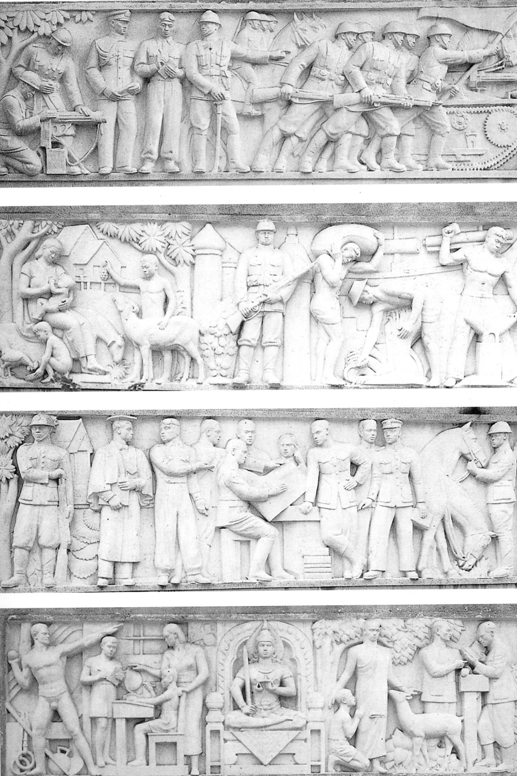

Silpa Bhirasri and his students, *Bas-relief panels at the bases of Democracy Monument*, 1939-1940, Cement, Bangkok

Source: The National Archives of Thailand, Bangkok, Thailand

**References and further reading**

Apinan Poshyananda (1992), *Modern Art in Thailand. Nineteenth and Twentieth Centuries*, Singapore and New York: Oxford University Press.

Michaelsen, Helen. (1993) “State Building and Thai Painting and Sculpture in the 1930s and 1940s,” in Clark, John, ed., *Modernity in Asian Art*, University of Sydney East Asian Studies No. 7, Sydney: Wild Peony.